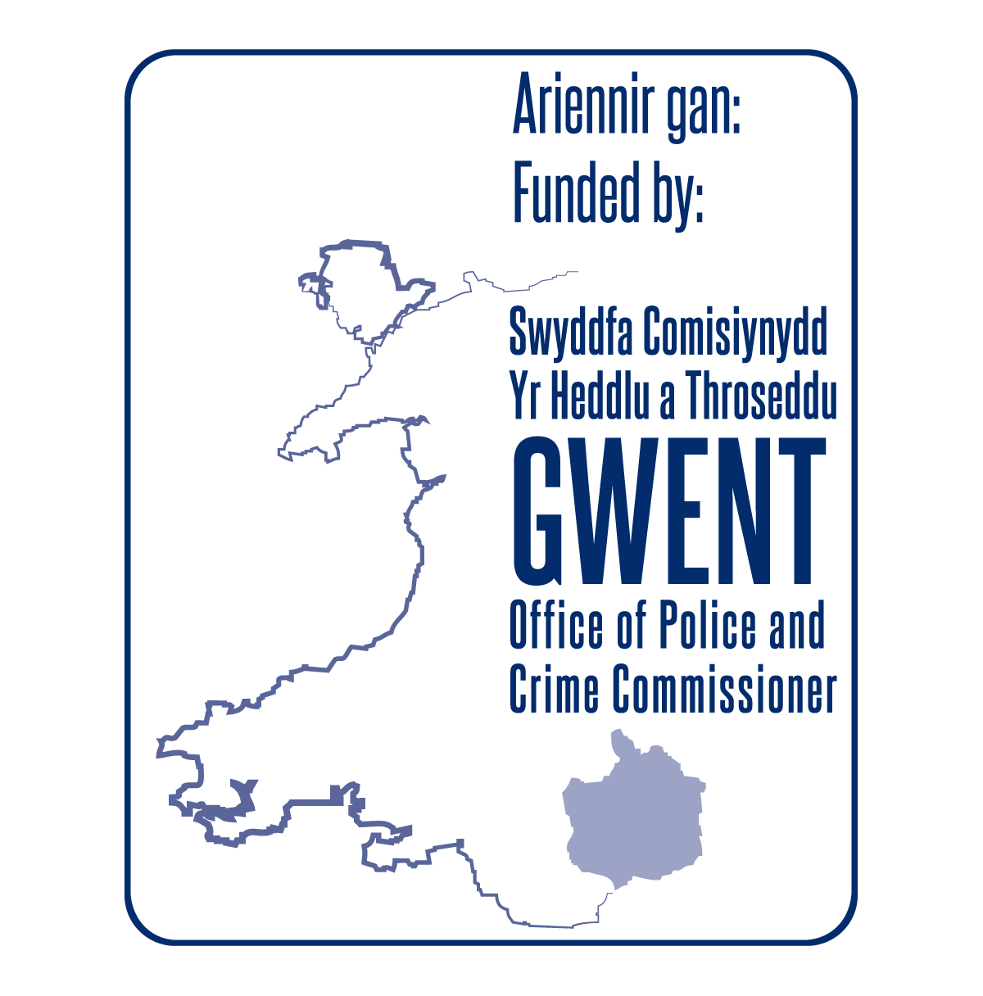
Role Profile

Role: Victim Services Case Worker (Voluntary)

Purpose: Provide practical and emotional support to victims

of crime and antisocial behaviour in Gwent

Location: Travel

Hours: Flexible

Overview

Umbrella Cymru provides a range of services in relation to gender and sexual diversity, equality and inclusion. We take great care and pride in the services we offer and we aim to demonstrate this by giving people the best information and support we can. We keep flexibility at the heart of everything we do, and aim to provide support to people where they want it, how they want it and when they want it. As such, all staff and volunteers are required to provide flexible support, and undertake a range of tasks. Below are the key responsibilities for the role.

Key tasks / responsibilities

Emotional Support

- Act as point of contact
- Provide emotional outreach support
- Coordinate support delivery for clients

Listening / Befriending Support

- Act as a point of contact
- Provide impartial listening support
- Meet with clients for informal discussions

Signposting

- Research information about a variety topics and support services
- Direct and coordinate services based on clients’ needs
- Other signposting as necessary

Practical Support

- Contact service providers
- Advocate on behalf of clients
- Liaise with central office staff to coordinate practical support

General person criteria:

Every who works or volunteers with us must be able to:

- Consider other people’s views
- Work as part of a team and contribute to the success of a group initiative
- Work with people from diverse backgrounds
- Contribute the time and commitment that a long term project requires
- Maintain complete confidentiality
- Have respect for the beliefs and values of others
- Communicate effectively with members of the public
- Support and promote the organisations aims and values
- Act ethically and appropriately

Role specific criteria

Essential

- Good Communication skills
- Good time management skills
- Strong organisation or project management skills
- Good computer skills (particularly Word Processing)

Desirable

- Experience of supporting people / casework
- Experience of working or volunteering in the support sector
- Welsh speaking

Get in touch:

To apply for this position, please complete our online application form at www.umbrellacymru.co.uk/vacancies or request an application form –
email - vacancies@umbrellacymru.co.uk or call us on 03003023670.

